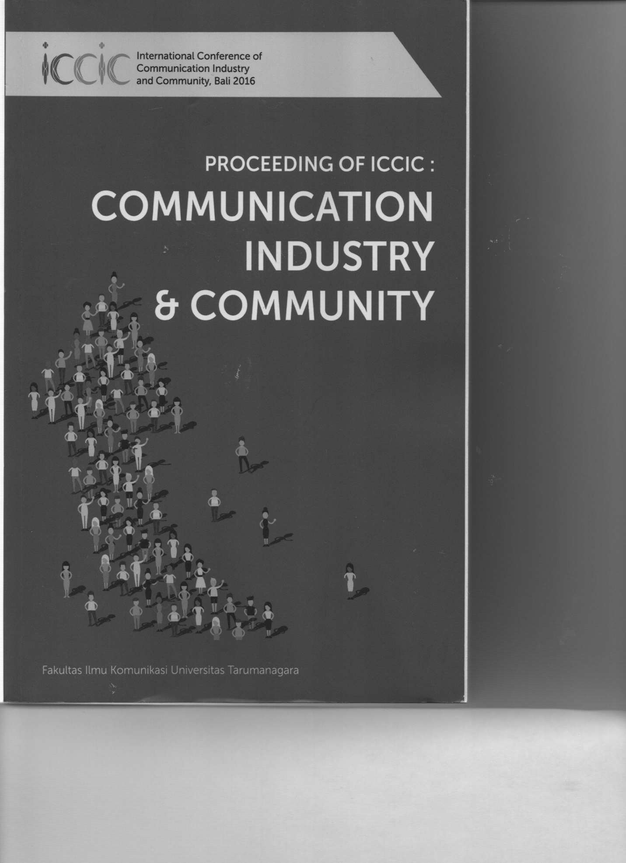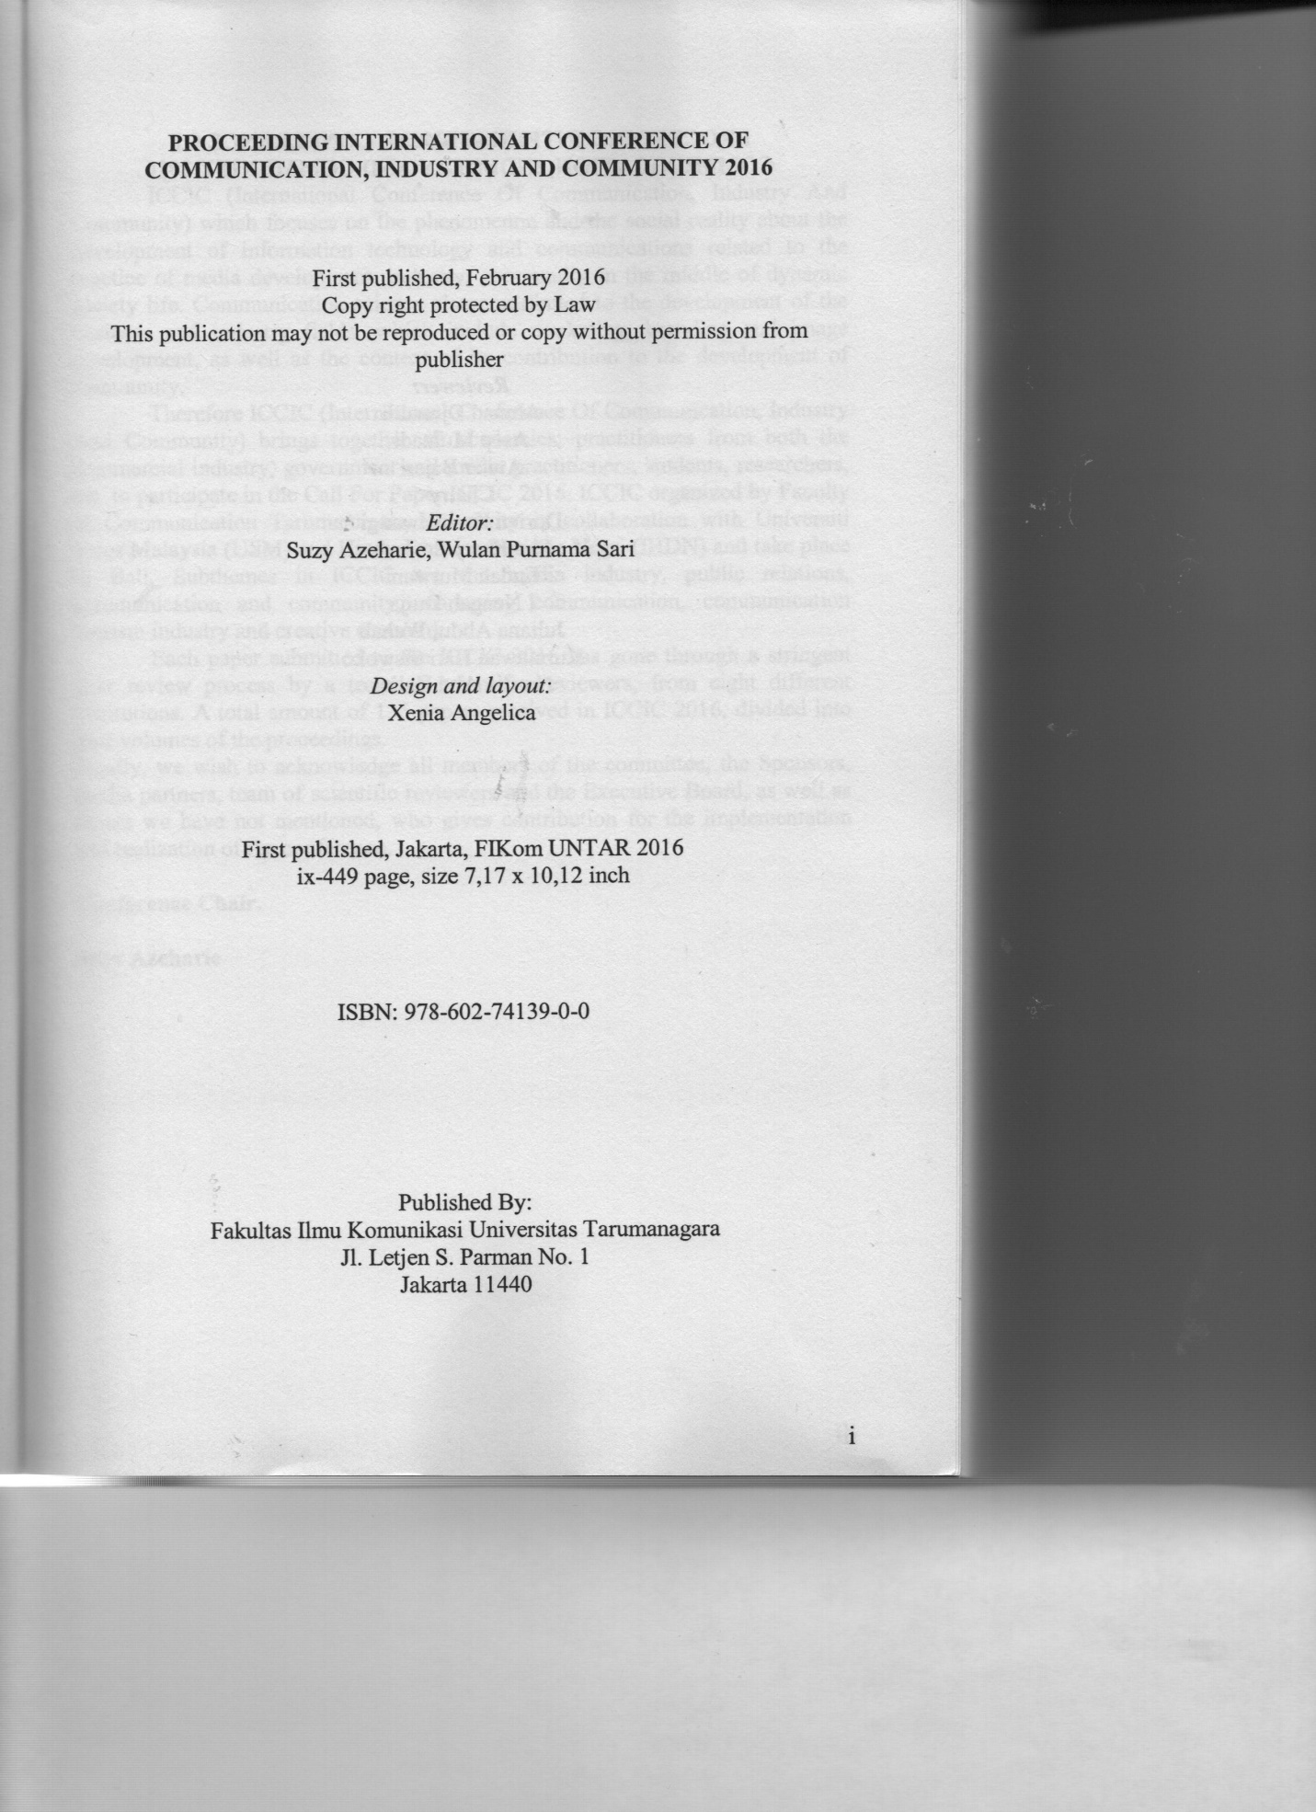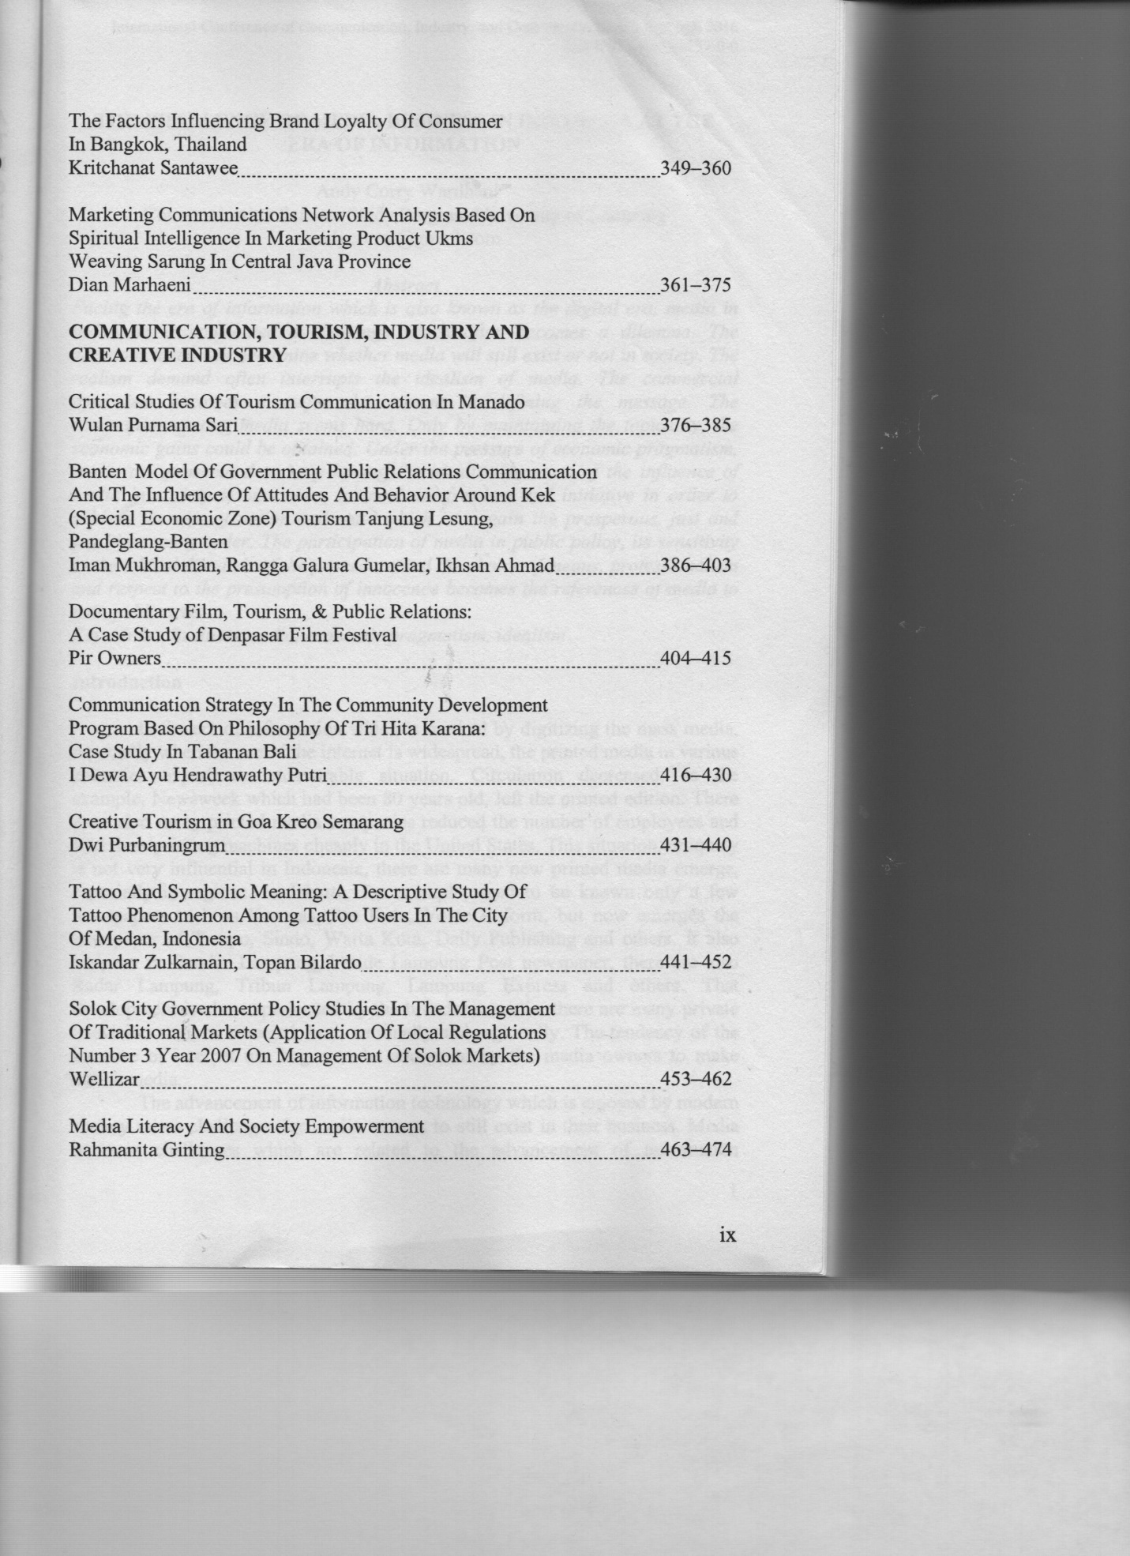MARKETING COMMUNICATIONS NETWORK ANALYSIS BASED ON SPIRITUAL INTELLIGENCE IN MARKETING PRODUCT UKMs WEAVING SARUNG IN CENTRAL JAVA PROVINCE

By Dian Marhaeni K, MSi.
Faculty of Communication Sultan Agung Islamic University
marhaeni@unissula.ac.id

Marketing of UKMs products is important to be attentive because it is directly related to economic growth and efforts to create a welfare society. Continuing research predecessor by researchers, who claim that spiritual intelligence-based performance contributed to the success of product marketing weaving sarung in Central Java. Sarung has promising opportunities in national and international markets. On the other side of the craftsmen and sarung sellers are in social and economic conditions that are heavily dependent on the owners of capital. Craftsmen and sellers still hanging with work orders and supplies of capital owners. They do not have the power to determine the price of the product. One possible cause is the use of the communication network and the communication network path is not optimal.
This study aims to reveal the flow of product marketing communication network sarung. This problem is very unique and distinctive to be revealed because it involves a social and cultural village-based workers and the use of traditional tools versus manufacturer.
The theory used is the analysis of communication networks which are then applied in the implementation of the marketing network of UKMs sarung. Marketing theory-based and spiritual and intellectual. Population and sample used as informants are craftsmen and traders environment of UKMs in the region of Central Java Province.
Data obtained by questionnaires and interviews. Primary data were then given the coding process and analyzed using the basic concept of a communications network that includes the types of relationships Mode One vs. Two modes, Directe vs undirected, symmetric versus asymmetric, and Weighted (valued) vs. Unvalued.
The conclusion of this study is needed communication network is known, capital assistance system software, and utilization of information and communication technology. Researchers suggest the support of the government, business and professional associations that work together with the community to make progress together.
This research is far from perfect, the coverage area is quite narrow, the other variables that it dominates the problems of UKMs products helped create obstacles for UKMs sarung product marketers.

Keyword: Network communications, product marketing, product UKMs.

PRELIMINARY
Network marketing communications is one of the important factors of success of a marketing program . Based on the results of previous research on the relationship spiritual emotional factors on the performance of the seller ( Asyari , Dian et al , 2014 ) , the spiritual aspect is an important factor in supporting the maturity of the personality of a salesman . But the research suggests that the results are not significant factors in the sales performance . Research conducted at the craftsmen and weaving and batik sarong sellers in Central Java province is generating leads fore the importance of marketing communication network and the ability of merchants and artisans in marketing the product their weaving.
Networks can be simply defined as a set of correlation / relationship between social actors . ( Kadushin in Eriyanto : 2014: 37 ) There are two important parts in the network analysis is the relationship between the actor and the actor . Actors in this study are individuals . While the link (edge ​​) is the relation between the link . Link is represented in a line that connects between the actor with other actors . The existence of an actor anatara lines indicate a relationship , otherwise no line indicates no relation.
Weaving craft is part of the creative industries that are of concern to the government. Given this industry based on the performance of the housing industry to absorb a lot of manual labor, but has not been able to prosper the craftsmen. On the other hand the results of the creative industry is gaining attention among the present. Product demand traditional nuances, art, natural products are becoming trens hobby and lifestyle of today.
Creative industries sector has a major role in contributing to state revenues, proven contribution to the gross domestic product on average 7.8 percent per year, equivalent to 140 trillion rupiah and should not be taken for granted because it is able to absorb a workforce of about 7.4 million people. From 2004 to 2010 exports of creative industries increased by an average annual growth of 12 percent and recorded the highest export value of 131 trillion rupiah in 2010, and is expected in 2025 creative industries accounted for 11 percent of GDP and 12-13 percent for export ( http://citraindonesia.com/kemendag-genjot-industri-kreatif).
Salesperson is one of the company's human resources who have a role in achieving the company's goals . Salesperson role in improving sales performance is very important , Sujan (1994 ) says that in order to achieve effective sales performance required salespeople who have high performance . Furthermore, in the pressure of global competition , companies including SMEs have to transform itself in order to create competitive advantage . A sustainable competitive advantage can be enhanced through the role of people in relationhsip marketing ( Schultz and Good , 2000) . Yavas (1997 ) in Fuad Masud (2004 ) shows the results of research on improving the performance of the sales force a deciding factor in the company's competitive advantage . Slater and Narver (1994 ) in his study found that the performance of our sales force to win the competition .
Emotional intelligence as a factor affecting the performance of HR has invited the pros and cons, where Gordon in Focus On Line (2004) and Carusso (1999) argues that intelligence (analytical skills and cognitive) is more important than emotional intelligence are more related to personality and mood (mood). Therefore the spiritual intelligence that was popularly believed to be able to integrate two other capabilities previously namely IQ and EQ (K., 2002) which can enhance the creativity and insight to the future. Zohar and Marshall (2001) says that the spiritual intelligence that is able to make a complete human beings as creatures who are intellectually, emotionally and spiritually.
This study aims to determine the marketing communications network based on spiritual intelligence on weaving artisans in the region of Central Java province. This study is a continuation of research the author and his colleagues previously found the model of the sales performance and batik sarong in Central Java that the results did not show a significant relationship between emotional factors mspiritual on sales performance. By entering the factor of marketing communications network in this study hopes to uncover other factors as supporting sales performance.

LITERATURE AND DEVELOPMENT HYPOTHESIS
2.1. Influence on Personality Spiritual Intelligence
Intelligence is a general ability to distinguish the quality of a person with another person (Joseph, 1978). Intellectual commonly called intelligence is a cognitive ability that is owned by the organism to adapt effectively in complex environments (Galton, in Joseph, 1978). Raven in Suryabrata (1998) defines intelligence as general capacity of individuals who appear in the individual's ability to cope with the demands of life in a rational way.
Intellectual Intelligence must be followed emotional intelligence called EQ (emotional quotient) as a subset of social intelligence that involves the ability to monitor the social feeling that involves the ability to others to sort out everything and use this information to guide our thoughts and actions (Shapiro, 1998) , In today's perkembanan, spiritual intelligence or Spiritual Quotient (SQ) and the behavior that puts our lives in the context of a broader meaning and rich, intelligence to judge that the action or the way a person's life is more valuable and meaningful (Zohar and Marshall, 2000).
Nugroho (2008) found that there are significant between intellectual ability and emotional capabilities of the performance, Devas (2008) found that intellectual capital positively affects job performance or the performance of a person. Hudani (2012) found that emotional intelligence has an influence on personality characterized by (awareness, openness to experience, extraversion and hospitality).
Based on the description above, the hypothesis proposed in this study are:
The higher the intelligence, the higher Spiritual personality
Salesperson

2.2. Spiritual influence to the performance Salespeople
In the study Barker (1999) states that the salesperson's performance can be evaluated using factors that are controlled by the salesperson itself based on the behavior of the salesperson and the final results obtained salesperson. Based on the study Barker (1999) the performance of the sales force can be measured by the ability to achieve a high market share for the company, the increase in the number of sales of products and the ability to sell products with high profit margins.
Witz, sujan H and M Sujan (1998) stated that a key factor in improving the performance of salespeople is to make intelligent sales personnel behaved in the works when conducting transactions with consumers. Pertanyataan is reinforced by Kumar (1994) in which the behavior of intelligent work has an influence on the performance of the sales force, because it will be easier to understand consumer behavior, it is easier to make decisions quickly.
The behavior of smart work will make a major contribution to the achievement of their performance primarily on the achievement of sales volume (Challagalla and Shervani, 1996). Boyatzia (2006) found the influence of emotional intelligence on the performance seseorang.Berdasar above description, the hypothesis proposed in this study is: The higher the spiritual intelligence, the higher the performance of salespeople

2.3. Theoretical Framework
Based on the description above, can be described theoretical framework in this study are as follows:

Communication network

SPIRITUAL intelligence
Personality
Product marketing

METHODOLOGY
3.1 . Research Framework
UKMs industrial products batik sarong is a typical excellent products and Central Java province make a significant contribution to economic development , but the development of the UKMs industry is still a lot of obstacles, in particular the development of human resources is still weak matrix corresponding SME issues central Java province in 2013. Plans this research will be conducted two years and targets to be achieved as follows :Detailed research framework presented in the following table :

Tabel.3.1 . Research Framework

Description | Year I | Year II
Destination | Getting a detailed overview of the field of UKMs sarong in the province of Central Java | Obtain a detailed picture of network marketing communications
Target | Getting the data based on the aspects of spiritual intelligence , personality salespeople on product marketing and development of UKMs | Empowerment model SDI UKMs
Data Needs | - Data UKM Provincial / the municipal and district  • Spiritual Intelligence | Network marketing
Data collecting method | Interview Questionnaire | To cross-check of data between stakeholders with the results of research and surveys
Analysis | Respondents analysis  UKM | Using UKM analysis to examine the relationship between the study variables .
Outcome | Overview of human resource development management of human resource development of UKMs | Development of UKMs with stakeholders
Output | - The research report  • journal Proceedings of the National and International • | Training spiritual intelligence and marketing communications network .

3.1. Population and Sample

Population is the whole subject of the research, while the sample is partially or representative of the population studied (Suharsisni Arikunto, 1998). The population in this study were 100 SMEs glove, weaving and batik in Central Java province which consists of the municipal Solo, Jepara district, the municipal Semarang, Kudus, Pekalongan district based on data from the Department Keperasi and SMEs in Central Java, 2013. The study population was all actors SMEs in Central Java which is focused on subsectors glove, weaving and batik. The respondents in this study is SMEs elected by 100 people who are willing to participate in this study. The sampling technique using sampling metodepurposive, through two stages.
The first stage of selecting SMEs of 5 kabupatan / the municipal elected that has many creative industry sub-sectors, namely batik sarong and Solo, Jepara, Kudus, Semarang and Pekalongan. In the second phase is sampling at selected SMEs to obtain 100 respondents in the sample, so that respondents are SMEs batik sarong elected in five selected districts. As for the consideration of the selection of samples is 1) SMEs glove, weaving and batik into superior products and typical Central Java province, 2) SMEs that operate more than one tahun.Adapun details of the number of samples from five selected districts. The third stage, to understand the communications network have been sampled two districts namely Boyolali and Sukoharjo only with consideration adequately represent the population.

3.3 . Variables Research and Measurement
This study will use a questionnaire of each variabeldengan using a Likert scale with a score of 1 to 5 from strongly disagree to skorsangat Agree . The operational definition table as follows :

Tabel 3.2. Definisi Operasional Variabel
Variable | Operational definition | Indicator | Measurement
Spiritual intelligence | The salesperson's ability to deal with the issue based on the orientation of life is more valuable and meaningful | 1. Honest  2. Openness  3. Knowledge of self | Scale interval data  ( with a scale score of 1 to 5 )
Network marketing communications | Groove marketing communications network | Network model | Quantitative descriptive

3.4 . Analysis Method
3.4.1 . Quantitative Data Analysis
The analysis technique used to answer the hypothesis is by using a structural equation modeling approach Partial Least Square ( PLS ) .Partial Least Square ( PLS ) PLS approach is a free distribution or a powerful research method because it does not assume certain distribution data but can be nominal , ordinal , interval and ratio as well as the number of samples should not be large ( Imam Ghozali , 2006: 17-18 ) .
3.4.2.Pengujian Model Partial Least Square ( PLS )
The test measures the empirical model based study Partial Least Square ( PLS ) with Smart PLS software is as follows :
Analysis of the relationship between variables teridiri lines of :
1. Outer models, the specification of the relationship between the latent variables
2. Inner Model , ie specifications relationships between the latent variables (structural model) , also called the inner relation.
3. WeightRelation , the estimated value of cases of latent variables , inner and oute rmodel provide specifications that are followed in the estimation algorithm PLS . After the required definition of weight relations . The value of cases for each variabe llaten estimated in plss sa following :
ξ_{b}= Σ_{kb}w_{kb}x_{kb}
η₁ = Σ_{ki}w _{ki}y _{ki}
Where Wkbv and WKI is kweight used to form estimates of endogenous latent variables ( η ) and exogenous ( ξ ) . Estimates of latent variables is linear aggregate of indicators that the value weightnyadidapat the estimation procedure PLS as specified by the inner and outer model where the latent variables endogenous ( dependent ) is η and the latent variables eksogenadalah ξ (independent ) , while ζ is a residual and β and ì is a matrix path coefficient ( pathcoefficient ) .
3.4.3 . Analysis of Network Marketing
Marketing network analysis to understand the flow and analyzed by quantitative descriptive method .

RESULTS AND DISCUSSION
4.1 . identity of Respondents
4.1.1 . age Respondents
The composition of the respondents based on age categories of respondents can be presented in Table 4.1 below:
Tabel.4.1
age Respondents

No | Age | Frequency | Precentage
1 | 20 – 29 year | 9 | 9
2 | 30 - 39 year | 24 | 24
3 | 40 - 49 year | 36 | 36
4 | 50 – 59year | 26 | 26
5 | >60 year | 5 | 5
Total |  | 100 | 100
Source : Primary data is processed , 2015

Age of respondents UKM,s batik sarong weaving industry has at least the age of 60 years or by 5 % , while the highest in the age of 40-49 years is sesesar 36 % . This condition indicates that the industry players batik sarong run by the age group 40-49 years were not productive age but has a strong entrepreneurial spirit .

4.1.2 . Education Respondents
The composition of respondents by category of education are presented in Table 4.2 below :

Table : 4.2
Education respondents

No | Education | Frequency | Percentage
1 | Graduate SD | 11 | 11
2 | Graduate SLTP | 15 | 15
3 | Graduate SLTA | 50 | 50
4 | Graduate PT | 24 | 24
Total |  | 100 | 100
Percentage Source : primary data processed , 2015

Education industry respondents batik sarong at least graduated SD sebesar 11 % and at most completed high school that is equal to 50 % This condition indicates that the industry players batik sarong is run by a group of people who have a good education is high school.

4.1.3 . Gender Respondents
The composition of respondents by category gender are presented in Table 4.3 below :
Table : 4.3
Gender Respondents

No | Education | Frequency | Precentage
1 | Male | 58 | 58
2 | Female | 42 | 42
Total |  | 100 | 100
Source : primary data processed, 2015

4.1.4 . Business long Respondents
The composition of respondents by category of business ever presented in Table 4.4 below:

Table : 4.4
Business long Respondents

No | Bussines Long | Frequency | Precentage
1 | 1–5year | 22 | 22
2 | 6 – 10year | 35 | 35
3 | 11 -15year | 13 | 23
4 | 16 – 20year | 10 | 10
5 | >20 year | 20 | 20
Total |  | 120 | 100
Source :primary data processed, 2015
4.2 . variable Description
Respondents' perceptions of the variables studied , this study uses kriteriarentang of 0.80 . Therefore, the interpretation of the value is as follows :

1,00 – 1,80 | = | Very low
1,80 – 2,60 | = | Low
2,60 – 3,40 | = | Medium
3,40 – 4,20 | = | High
4,20 – 5,00 | = | Very high
4.2.1 . Spiritual Intelligence
Indicator variables spiritual intelligence includes honesty, openness and self-knowledge . Based on research in the field of spiritual intelligence variable index shown in Table 4.5.
Table 4.5
Descriptive statistics Spiritual Intelligence

No | Indikator | Average Respondens answer
1. | Honest | 4.1
2. | Openness | 4.05
3. | Knowledge of self | 4.07
Overall average |  | 4.07
Source : primary data were processed , 2015 .
Table 4.9 shows that the overall average of respondents' answers by 4:07 . In detail, the average respondents honest indicator of 4.1 , openness 4,05 andknowledge dirisebesar 4:07 .
It shows that the respondents' perceptions of spiritual intelligence is high . It is based on findings in the field can be presented as in Table 4.6 below:

Table 4.6
Descriptive Spiritual Intelligence

No | Criteria | Indicator |  | Invention
1. | High |  | Honest | - Describe the product with what  • Sell at a reasonable price  • As promised and on time
2. | High | Openness |  | • Explain what the  • Open to the community and family  • Consumers are invited to get involved  • Inviting customers to participate in the community
3. | High | Knowledge of self |  | - Describe the style and quality of products  • To advise on the suitability of the product to the buyer  • Choice of products according to customer needs
Source : Primary data processed, 2015.
4.3 . Data analysis
Data processing techniques to the study inimelalui 2 testing phase, ie outer and inner models models.
4.3.1 Outer Model or Measurement Model
Use of PLS Smart program as a means of Data Analysis to Determine the outer results of the models can be done through : Convergent Validity , Discriminant Validity , and Composite Reliability.
a. Validity convergent
Validity melaluiConvergent analysis of the measurement models with reflection indicator assessed based on the correlation between item scores / component scoreyang estimated by PLS software . The size of individual reflection tingggi said when correlated over 0.70 with the construct being measured . However , According to Chin , 1999 ( in Ghozali , 2006) to study the early stages of development of measurement scale loading value of 0:50 to 0.6 is Considered adequate .

Table 4.7
Outer Loadings ( Measurement Model )

Variable | Indicator | Loading factor | Conclusion
Spiritual intelligence | Honest | 0.858 | Valid
 | Openness | 0.883 | Valid
 | Knowledge of self | 0.838 | Valid
Source : primary data processed, 2015

From Table 4.7 above shows the outer value model or the correlation between the constructs with variable indicates that the loading factor has a value above 0.50 for all the variables that constructs prove that the indicators are valid.

a. Discriminant Validity
To ensure that every concept of latent variables each different from the other variable is done by looking discrimainant validity. Descriminant model has good validity if any value loadings of any indicators of a latent variable loadings have the greatest value to the value of the other loadings on other latent variables (attachment).
Composite Reliability and Average Variance Extracted
Testing the validity and reliability of the data can also be seen from the average variance extracted (AVE). Construct is said to have a high reliability if the composite reliability values> 0.60 and AVE are above 0.50. On the table will be served 4:20 composite reliability and AVE values ​​for all variables.
Table 4.8
Composite Reliability and AVE

Variable | Composite Reliability | AVE
Spiritual intelligence | 0.895 | 0.739
Source : primary data processed , 2015 .

4.8 According to the table above it can be concluded that all constructs reliably meet the criteria . This is indicated by the value of Composite Reliability above 0.60 and above 0.50 AVE .
Source : Primary data is processed , 2015

4.3.3 . Testing Interpersonal Variables
The amount of influence between the variables of research can be seen on the output result of the inner weight , the 4.22di table below.
Table 4.9
Result For Inner Weight

 | original sample estimate | mean of subsamples | Standard deviation | T-Statistic
Spiritual -> Marketing | 0.147 | 0.133 | 0.080 | 1.843
Primary data are processed, 2015.

4.3.4. Hypothesis Testing and Discussion

4.3.4.1. Spiritual intelligence influence on personality
Based on Table 4:22, the third hypothesis testing results indicate spiritual intelligence significantly affect personality, with a path value of 0.396 and 4.823 t value greater than t table (1.96). Thus it can be concluded that spiritual intelligence has a positive and significant influence on the personality. These results indicate that the higher intelligence where the higher sprititual honesty, openness, self-knowledge it will increase the seller's personality, especially the increase in extraversion, openness and self-knowledge. With the acceptance of the hypothesis is meant to support the study of Zohar and Marshall (2001) and K. (2002) that the role of the SQ can increase the seller can improve the ability to adapt effectively to the complex environment (Galton in Joseph, 1978).
Therefore, by increasing the spiritual intelligence with more honest, openness and knowledge of the seller, the seller's ability to build communities, networks, precision and better cooperation.

4.3.4.2. Influence of Spiritual Intelligence to marketing
Based on Table 4:22, the sixth hypothesis testing results indicate spiritual intelligence does not significantly affect the performance of the sales force, with a path value of 0.147 and 1.843 t value is smaller than t table (1.96). Thus it can be concluded that the spiritual quotient has not had a significant effect on the performance of the sales force. These results indicate that spiritual intelligence can not improve the performance of the sales force is increasing its market share, speed and the ability to sell new products to reach the target and a bigger profit.

4.3.4.3.Analisis Network Marketing Communications
This study used a sample of craftsmen weaving centers Gatak area Sukoharjo and Ngemplak Boyolali. There are a number of 71 craftsmen and some of them are a craftsman and collectors. Meanwhile in Sukoharjo Gatak Blimbing there are 35 of them are artisans and craftsmen and collectors. Crafters are energy weavers weave their own at home or at the employer's premises. Collectors are the people who buy the weaving of artisans. As for the marketing communications network overview is as follows:

Figure 1. Network Marketing Communications 1
R
Q5
Q1
Q6
Q2
Q3
Q4
P1
P2
P3
P1
P2
P3
P1
P2
P3
P1
P2
P3
P4
P5
P1
P2
P3
P4
P5
P6
P7
P1
P2
P3
P4
P5
P6
P7
P8
P9
P10
P11
P12
P13
P14
P15
Boyolali

From the description of the marketing network can be described diarea first artisan center that is centralized marketing communications. Woven marketing communication has not been done independently. The same condition also occurs in the second weaving centers. These artisans work order. They got yarn, design and direct buyers of the employer in Solo. Crafters are not entitled to ultimately determine the price of weaving. The employer who determines the price. Crafters is dependent upon the employer.
During the marketing of weaving has never marketed itself, because if you get caught employer will not be given another job. The craftsmen will receive a reward of 80 thousand, 70 thousand, 60 thousand, 50ribu, 35ribu per meter depending on the quality of the weaving. Results Blimbing Gatak weaving artisans will be exported to Arab and Surabaya. Penyetornya is the employer. Each employer can buy at different prices. While the marketing communications network in the second weaving centers are as follows:

Figure 2: Network Marketing Communications 2

R
Q1
Q2
Q4
Q3
P1
P2
P3
P1
P2
P1
P2
P3
P4
P5
P6
P7
P1
P2
P3
P4
P5
P6
P7
P8
P8
P9
P4
P5
P6
P7
P8
Q5
P1
P2
P3
P4
P5
Sukoharjo

Marketing conditions weaving experience different phenomena with centra artisans weaving looms 2. The production will run in accordance with the order. If demand decreases or stops then the product will be congested. But if the order is plentiful or lot or large it looms orders will be awaited by collectors. Chairman Mr. Wiyono, Secretary Darmi mother.
Number of collectors in this center there are four collectors. This is the price setter for collectors, crafters can not specify the price because the position is very dependent on collectors. Production craftsmen also can not every day having to wait for the stock pile of collectors. Collectors from outside will sell woven by order in East Java. There are collectors who sell directly or to deposit again.
Messages weaving Arab traders came and gave the capital first. Collectors bought the yarn and look for craftsmen. The Arab swords also known easy to negotiate with for example if it is determined the order turns out not so, then they will wait. They advised that the manufacture of woven on hand crafters can not be forced like machines.
During this time artisans memamg never marketed itself. No installation of the internet or look for its own network. The reason is because the craftsmen are the parents and do not understand the media. Likewise, there is no coach who can menjari them with this medium.
With these conditions the weaving craftsmen share their time with other work that could bring value. Such as in the fields, has Klangenan or pets that can be sold. Production looms 40m / day or in 5 pieces of over 8 meters. The artisans will earn wages 2,500 rupiah per meter.
Expectations of the future, the first order can be varied looms for the manufacture of other products that could be worth selling. Search of raw materials originally provided by sub or head of the group but because constrained deposit jammed the artisans buy sendiiri own. Reason stalled as a result of the sale of weaving used to cover the daily needs are not sufficient, so that when benag exhausted incapable mebeli again. While the selling price and the thread remains limited. Another obstacle because the stock is still a lot of reasons, so collectors do not want menerina.
Other expectations, it took the creation of new products, there are mengakari, capital assistance, support tools and marketing assistance. During this time the product is sold 11 thousand but to be 35-40 thousand in Arabic. Depositing system in Arabic. There are Arab traders who came to demand a minimum of 50 one-week score. So marketing is not at the initiative of artisans. So far there has been no attempt ntuk crafters looking to overseas marketing network. Because demand a lot and had large capital. Collectors do not dare to approve because no ditas black and white or a clear written agreement. So that the customer does not come worry later.
By knowing the woven product marketing communications network in Central Java is expected to have the discovery of specific factors that become important variable success in the field marketing.However Network is centralistic dependent on the economic aspects, namely capital.

CONCLUSIONS AND RECOMMENDATIONS
5.1. Conclusion
1. Spiritual intelligence is not significant to the performance of the sales force, just emotional intelligence significantly to the performance of the sales force.
2. Network Marketing communications is a major actor in improving marketing performance woven products in Central Java.
3. Capital and the power of communication networks supported pemsaran information technology needed to support the success of marketing communications.

5.2. Recommendation
1. The Government needs to sell or salesmanship skills training and spiritual intelligence training.
2. The creative industry SMEs loom constantly innovate and build better relationships with customers, build a network of marketing communications wider, so that the presence of creative industries more widely known.
5.3. Limitations Research
This research focus on the creative industry sub-sectors of weaving and the studied variables are limited to intelligence, spiritual and communication network. Penggambilan sample is confined in five regencies / the municipal elected, with a total sample of 100 respondents.
In the next study expected a lot more to add other variables that can affect the marketing of weaving. Such as government policies.

BIBLIOGRAPHY
Asyhari, 2013, the Innovation and Creativity Development Model-based Triple Helix to Improve the Performance of Creative Industries in Central Java (competitive grants), Unissula, Semarang.

Asyhari, et al, 2014, Model-based sales force increase is intellectual, emotional intelligence and spiritual intelligence on product sales force and batik sarong in central Java province, (Grant compete), Unissula, Semarang.

Baldauf, A.David.W, Cravens and Nigel F. Piercy, 2001, "Examining Business Strategy, Sales Management and Sales Organization Salesperson antecedents of effectiveness", Journal of Personal Selling and Sales Management.

Barker, Tansu A, 1999, the "Benchmark of Successful Performance Salesforce. Canadian Journal of Administrative Science.

Boyatzis, R, E, Ron, S 2001, Unleashing the Power of Self Directed Learning, Case Western Reserve University, the Cleveland, Ohio, USA.

Ministry of Trade of the Republic of Indonesia, 2008, the Creative Industries Study of Indonesia.
Eriyanto, (2014), Analysis of Network Communications, Jakarta, Prenada Media.

Ghozali, Imam 2005, Persmaan Structural Model, Concepts and Applications with AMOS Ver.50 Program, Diponegoro University Publishing Agency, Seamarang

Ghozali, Priest, 2005 Applications Multivariate Analysis With SPSS program, the Agency Publisher Diponegoro University, Semarang.

Sujan, haris, Barton A. Weitz and Nirmalaya Kumar, 1994. "Learning Orientation, Working Smart and Effective Selling, Journal of Marketing.

Mudrajat K 2006, Strategy, How Achieving Competitive Advantage, grants, Jakarta

Biodata peneliti
Dian Marhaeni K, S.Sos,MSi, lahir di Kulon Progo, 15 Juni 1970. Lulus S1 dan S2 di Universitas Sebellas Maret Surakarta, 1996 dan 2006. Staf pengajar di Fakultas Ilmu Komunikasi Universitas Islam Sultan Agung Semarang. Koordinator kegiatan Pengabdian Masyarakat di Fakultas. Aktif kegiatan penelitian dan mengikuti forum ilmiah nasional. Riset yang sedang digarapnya saat ini adalah rekonstruksi kajian Public Relations dalam perspektif nilai-nilai Islam.

